Access control
Authentication vs. Authorization, IDOR, and Horizontal / Vertical Access Control
Introduction and Lab Report
Lab: URL-based access control can be circumvented—PortSwigger Web Security Academy
Prepared by: Nihar Mane

INDEX
PART 1 INTRODUCTION
1. Introduction................................................................................................................................................. 2
2. Authentication vs. Authorization.................................................................................................................. 2
2.1 It’s working ................................................................................................................................... 2
2.2 Comparison Table......................................................................................................................... 2
3. Insecure Direct Object References (IDOR)................................................................................................. 3
3.1 Root Cause................................................................................................................................... 3
3.2 Worked Example........................................................................................................................... 3
3.3 Where IDOR Hides Beyond the URL............................................................................................ 3
4. Horizontal Privilege Escalation.................................................................................................................... 4
5. Vertical Privilege Escalation........................................................................................................................ 4
PART-2 LAB REPORT
2.1 Report Metadata…………………………………………………………………………………………..…...…..6
2.2 Executive Summary………………………………………………………………………………………..…...…6
2.3 Scope……………………………………………………………………………………………..…………………6
2.4 Methodology and Root Cause…………………………………………………………………..………………..6
2.5 Step-by-Step Execution………………………………………………………………………..………………….7
2.6 Impact Assessment……………………………………………………………………………..…………...…...11
2.7 Remediation……………………………………………………………………………………..………………..11
2.8 Conclusion………………………………………………………………………………………...………………11
References.....................................................................................................................................................11

- Introduction
Access control bugs have been the most common class of web vulnerabilities, according to both the frequency of reports and OWASP: Broken Access Control is number 1 on the 2021 Top 10 list. But the catch-all term "access control" can actually refer to several distinct failure modes that require tailored testing and remediation. This report is meant to clarify the terminology used before presenting the actual lab write-ups: authentication is split from authorization, Insecure Direct Object Reference is presented as a distinct class of issues, and horizontal and vertical privilege escalation are contrasted.
This report is also part of the concept-reference family of materials: unlike the individual labs, it does not describe a particular vulnerability instance. It continues the series that started in Week 1 with the Host Header labs: the theme is the logic that underlies the trust in one particular HTTP header field leading to account takeover. The two authentication labs from Week 2, Username Enumeration via Different Responses and 2FA Simple Bypass, fit into the same category of authentication flaws. The following labs will focus on authorization, and this report serves as a prerequisite to understanding them.

- Authentication vs. Authorization
2.1 It's working:
Authentication answers the question “Who are you?” It is the process of asserting some identity, usually by which a user (or service) provides credentials—for example, a username plus a password, an OTP, a hardware token, or an identity from a federated identity provider. On a successful authentication, a session (usually represented by a cookie, possibly a JWT or a server-side record) that the app will use for subsequent requests is created.
Authorization answers the question, "Now that I know who you are, what are you allowed to do?” It checks on every action a user takes—when they look at an invoice, change their profile, delete a comment, or open an admin panel. It always depends on the resource being accessed—not just who is trying to access it.
2.2 Comparison table,
Parameters | Authentication | Authorization
Core question | Who are you? | What are you allowed to do?
When enforced | Once, at login (and step-up moments) | Continuously, on every request
Typical mechanism | Password, OTP, biometrics, SSO/SAML/OIDC | RBAC/ABAC checks, object ownership checks
Session artifact | Cookie / JWT / server session created | No new artifact—checked against existing session
Example failure | 2FA bypass, credential stuffing, enumeration | IDOR, horizontal/vertical privilege escalation
OWASP mapping | A07:2021—Identification & Auth Failures | A01:2021—Broken Access Control
- Insecure Direct Object References (IDOR)
3.1 It’s Root Cause
IDOR occurs when a web application directly references an internal object (database row, file, account), allowing the request to access or manipulate the reference without independently verifying that the user making the request is the rightful owner of said object. The actual ID can be easily guessed (simple integer) or totally opaque (UUID); the issue here is the lack of any ownership check, and the predictability of the ID is irrelevant. Making the ID more difficult to guess just makes scanning take longer; it doesn’t address the flaw.

3.2 Working Example
Consider a website that uses the following URL to load a customer's account page, retrieving the record directly from the back-end database:
https://insecure-website.com/customer_account?customer_number=132355
Here, the customer_number is used directly as a record index in queries performed against the back-end database. If no other controls are in place, an attacker can simply modify the customer_number value, bypassing access controls to view the records of other customers — an IDOR vulnerability leading to horizontal privilege escalation.
The same pattern shows up just as often with static files rather than database rows. A website might save chat transcripts to disk using an incrementing filename, and serve them back on request:
https://insecure-website.com/static/12144.txt
An attacker can simply modify the filename to retrieve a transcript created by another user, potentially exposing credentials or other sensitive data. In both cases the request is authenticated — the attacker has a valid session — but it is never authorized against that specific object; the server's only check is “does a record/file with this identifier exist,” not “does it belong to the currently authenticated user.”

3.3 Where IDOR Hides Beyond the URL
• Body parameters in POST/PUT/PATCH requests (account_id, user_id, order_id fields inside JSON payloads).
• Hidden or disabled form fields that get re-enabled or replayed with a modified value.
• API path segments, e.g. /api/v2/users/{id}/invoices, tested by substituting adjacent IDs.
• Multi-step workflows where an object reference issued in step one (a quote ID, a cart ID) is trusted without re-validation in step three.
• GraphQL and batched REST endpoints, where object references can be smuggled inside a single query alongside legitimate ones.

- Horizontal Privilege Escalation
Horizontal privilege escalation is a situation where a user gains access to another user’s data or functionality of the same privilege level. For instance, one customer reads another customer’s data. In this case, the customer would not gain access to the administrative functions. The IDOR (Insecure Direct Object Reference) is the most prevalent technique for performing horizontal privilege escalation attacks. However, this term is not interchangeable with horizontal privilege escalation. The IDOR is a security issue that utilizes insecure object references, while horizontal privilege escalation refers to the elevation of privileges that occurs between users of the same level.
Working example:
https://insecure-website.com/myaccount?id=123
If an attacker changes the id parameter to another user's value, they can load that other user's account page—along with whatever data and functionality lives there—because the server is trusting the client-supplied id instead of deriving the account from the authenticated session.

- Vertical Privilege Escalation
Vertical privilege escalation refers to obtaining access to functions available to a higher privilege account. An example would be a regular user accessing administrator functions, a customer support agent accessing billing functions, or an unauthenticated user accessing a resource that is supposed to be restricted to any authenticated user. In general, this privilege escalation type is more severe than the horizontal type since the impact is larger depending on the privilege level attained.
Two common patterns
• Missing function-level access control — an admin panel is reachable simply by knowing or guessing its URL (e.g. /admin/users), because the server never checks the caller's role before rendering the page or executing the action.
• Client-side-only enforcement — the front end hides an “Admin” menu item, but the underlying API endpoint it calls performs no server-side role check, so the request succeeds if sent directly (via a proxy tool, a saved request, or a script).

Working example:
From that same PortSwigger page, under Vertical privilege escalation, their example is under "Unprotected functionality":
A website hosts sensitive admin functionality at a predictable URL:
https://insecure-website.com/admin
Even though this page might only be linked from an administrator's welcome screen, nothing stops a regular, non-admin user from just typing that URL into their browser directly and reaching the same functionality—because the server never actually checks the caller's role; it only relies on the link not being shown to them.
PortSwigger also walks through the "security by obscurity" variant of the same flaw: instead of a guessable /admin path, the app hides it behind an unpredictable URL like
https://insecure-website.com/administrator-panel-yb556

That still fails as an access control, because the URL can leak elsewhere—their example shows client-side JavaScript that builds the UI conditionally:
var isAdmin = false;
if (isAdmin) {
var adminPanelTag = document.createElement('a');
adminPanelTag.setAttribute('href', 'https://insecure-website.com/administrator-panel-yb556');
adminPanelTag.innerText = 'Admin panel';
}

Even though the link is only rendered for admins, the script containing the hardcoded URL ships to every user regardless of role—so any non-admin can read the page source, extract the URL, and browse straight to it.

PART 2-> Lab
2.1 Report Metadata

Lab Name: URL-based access control can be circumvented
Platform: PortSwigger Web Security Academy
Vulnerability Type: Vertical Privilege Escalation / URL-based Access Control Bypass

2.2 Executive Summary

This lab report documents the analysis and exploitation of an insecure URL-based access control vulnerability on the PortSwigger Web Security Academy target application. The application attempted to restrict access to administrative functions based solely on URL path filtering at the front-end or reverse proxy level. By injecting custom header routing parameters (X-Original-Url), the access control check was successfully bypassed, enabling unauthenticated/low-privileged execution of restricted administrative actions (deleting user carlos).

2.3 Scope

Target Application: PortSwigger Web Security Academy lab instance (https://<lab-id>.web-security-academy.net).
Tested Vectors: Direct browsing to /admin, HTTP request manipulation via Burp Suite, and header-based override testing utilizing X-Original-Url.

2.4 Methodology and Root Cause

Root Cause: The application relies on a front-end component or reverse proxy to block requests containing restricted URL paths (such as /admin). However, the back-end server trusts incoming request override headers (like X-Original-Url) to determine the underlying routing target without validating whether the user possesses the necessary administrative role, resulting in an authorization bypass.
Methodology: Passive reconnaissance, traffic interception with Burp Suite Proxy, analysis of access restrictions, and header injection in Burp Repeater

2.5 Step-by-Step Execution

Step 1: Attempted to navigate directly to the /admin path in the browser; observed an "Access denied" response.
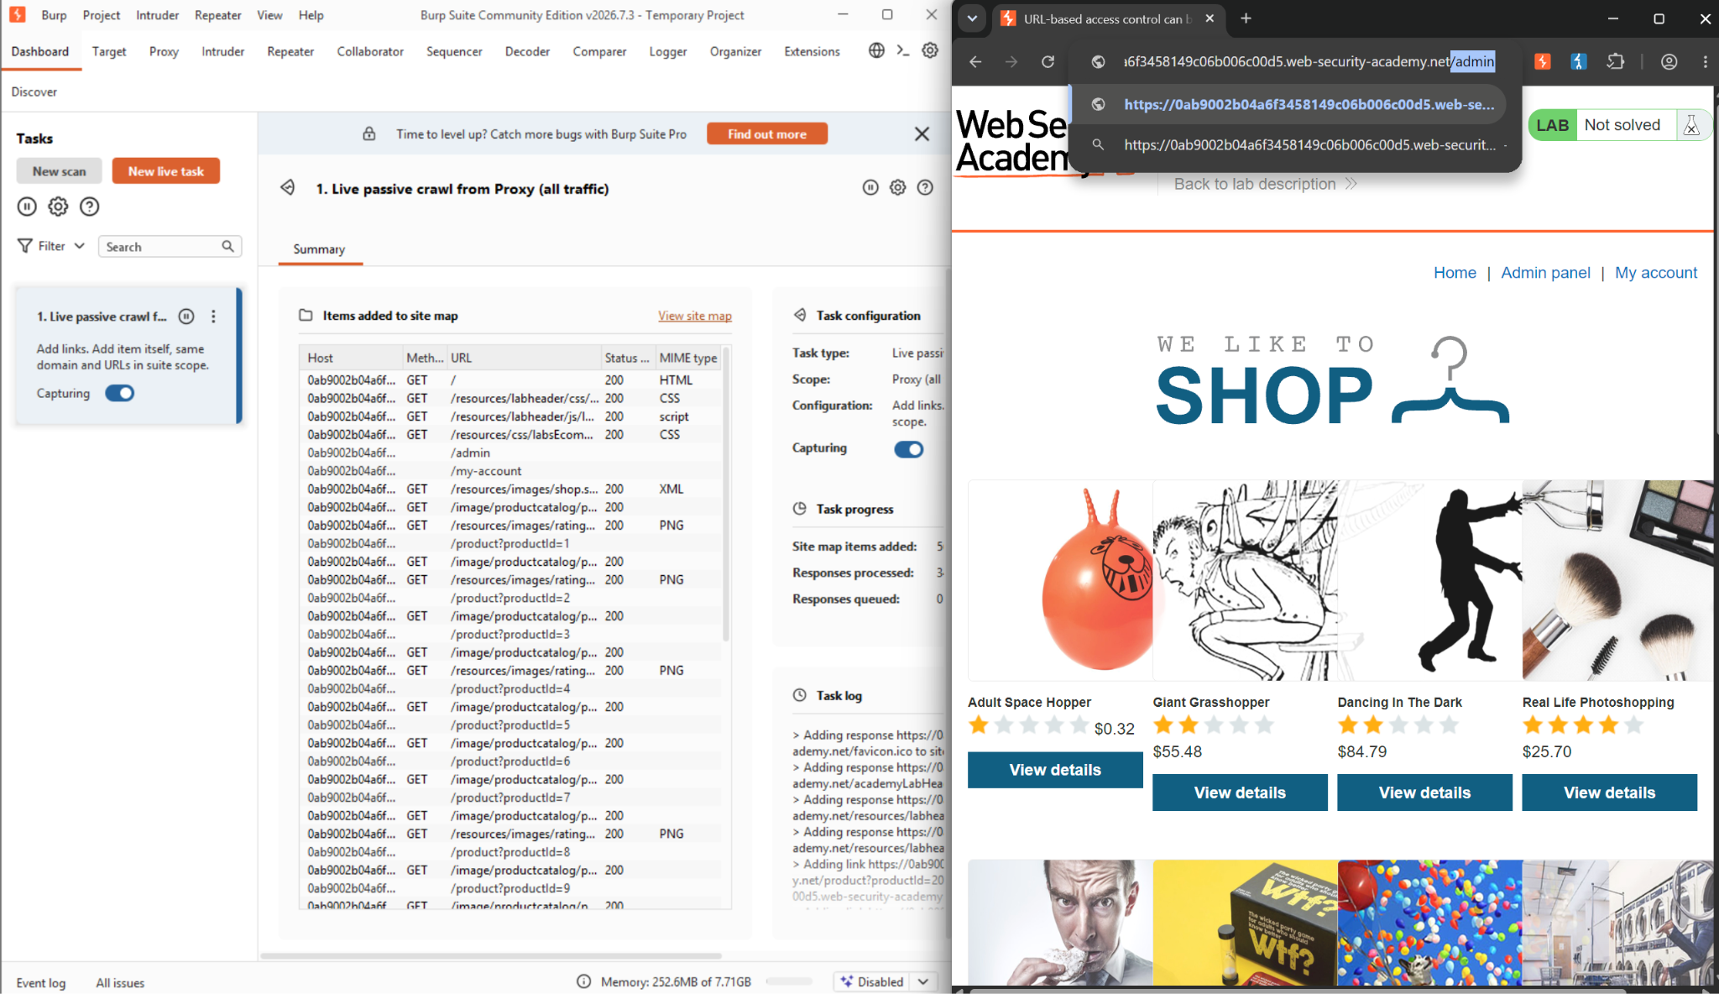
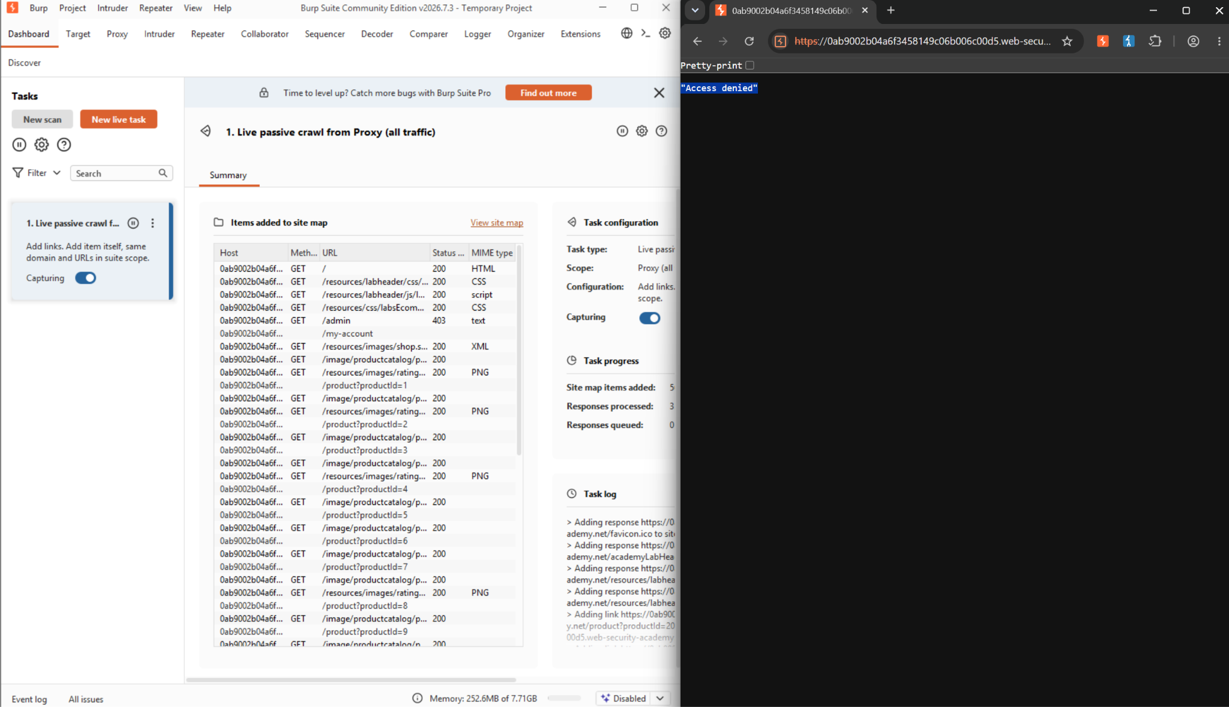

Step 2: Configured Burp Suite Proxy to intercept traffic and captured the incoming GET request targeting /admin.
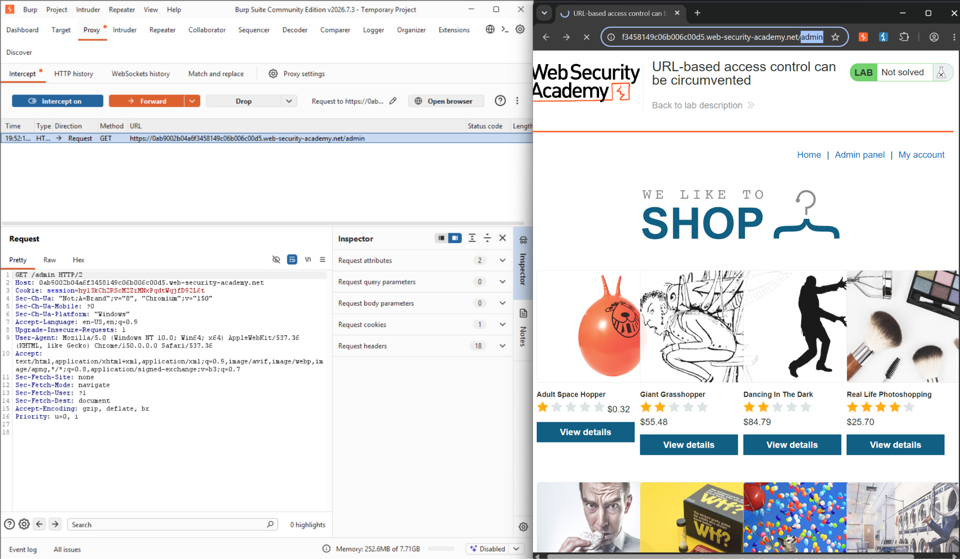

Step 3: Right-clicked the intercepted request and selected Send to Repeater.
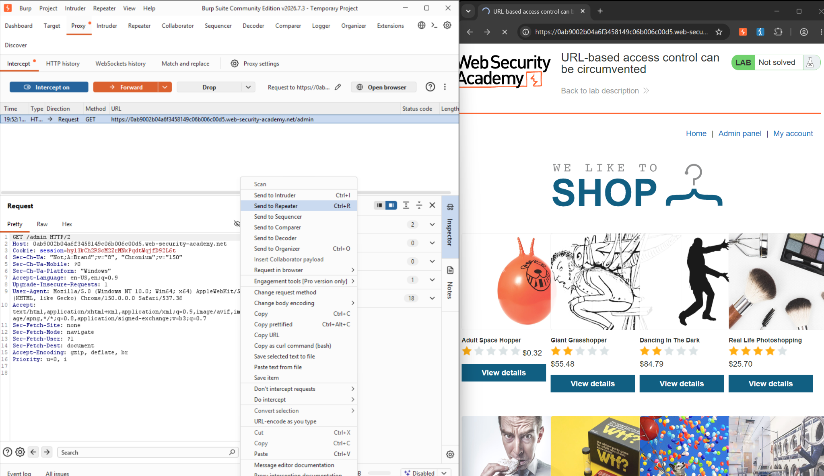

Step 4: Tested backend behaviour with an invalid path override (X-Original-Url: /invalid), observing a 404 Not Found response, confirming that the backend honours the custom header.
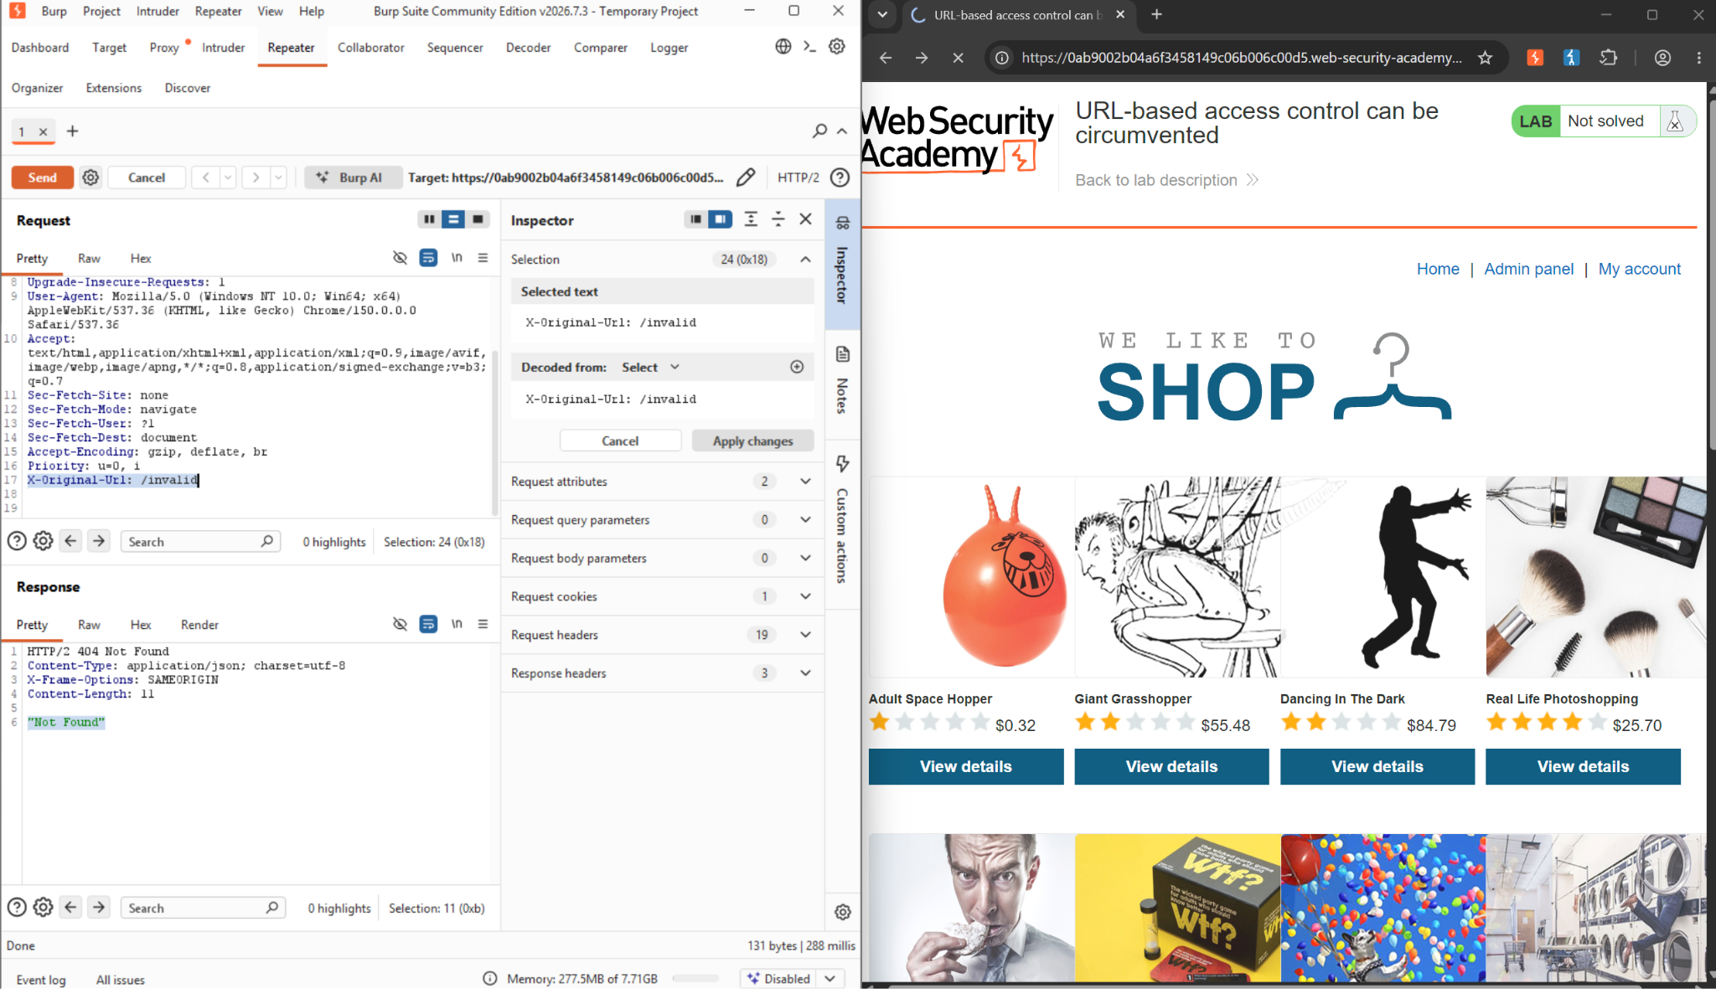

Step 5: Tested supplying /admin via the X-Original-Url header while requesting a standard permitted endpoint
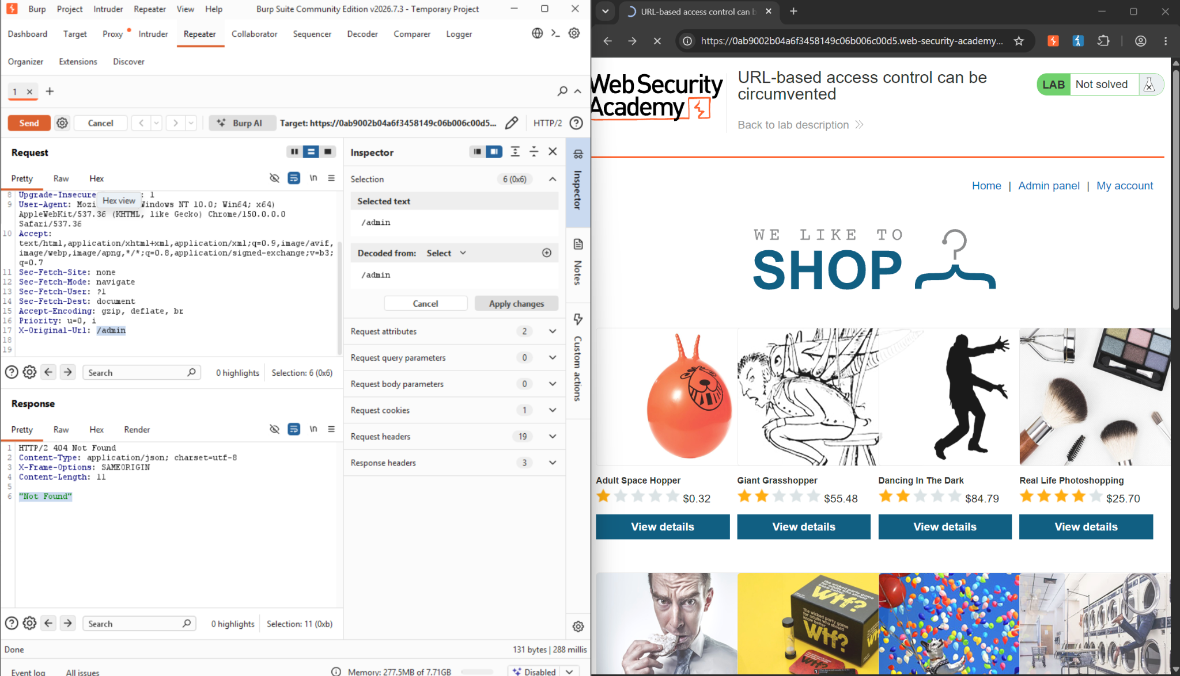

Step 6: Adjusted the request line to target a valid user context (GET /?username=carlos) and set the X-Original-Url header to/admin/delete to trigger administrative deletion functionality.
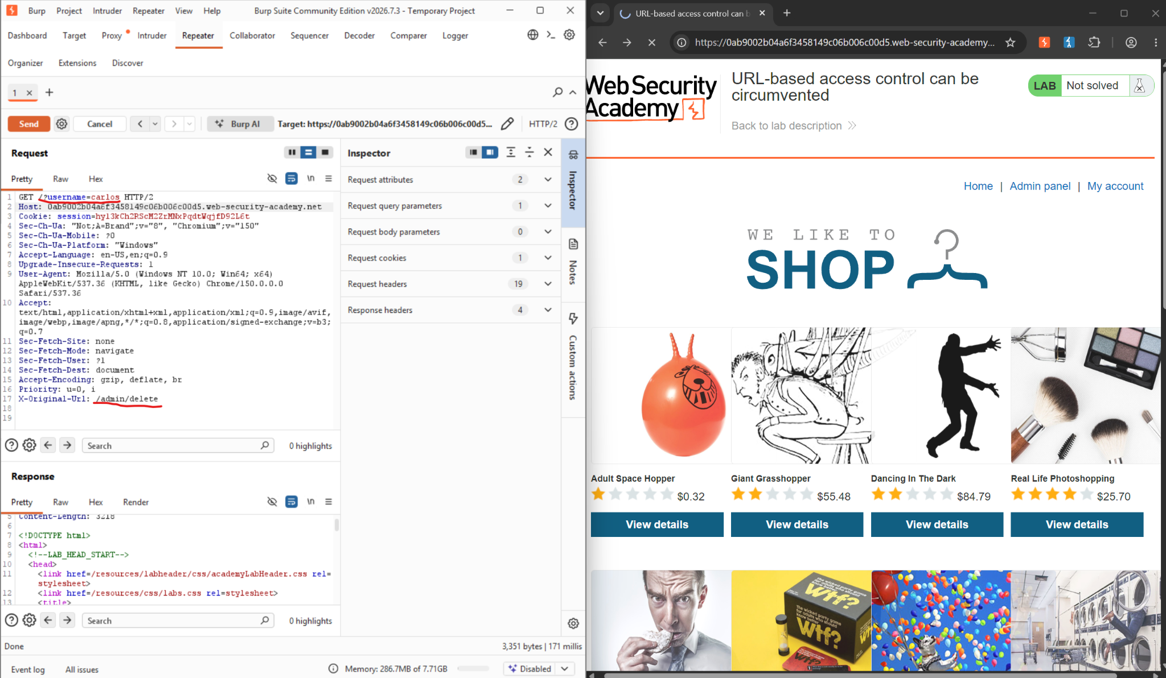

Step 7: Sent the request, receiving a 302 Found response, and successfully solving the lab by deleting user Carlos.
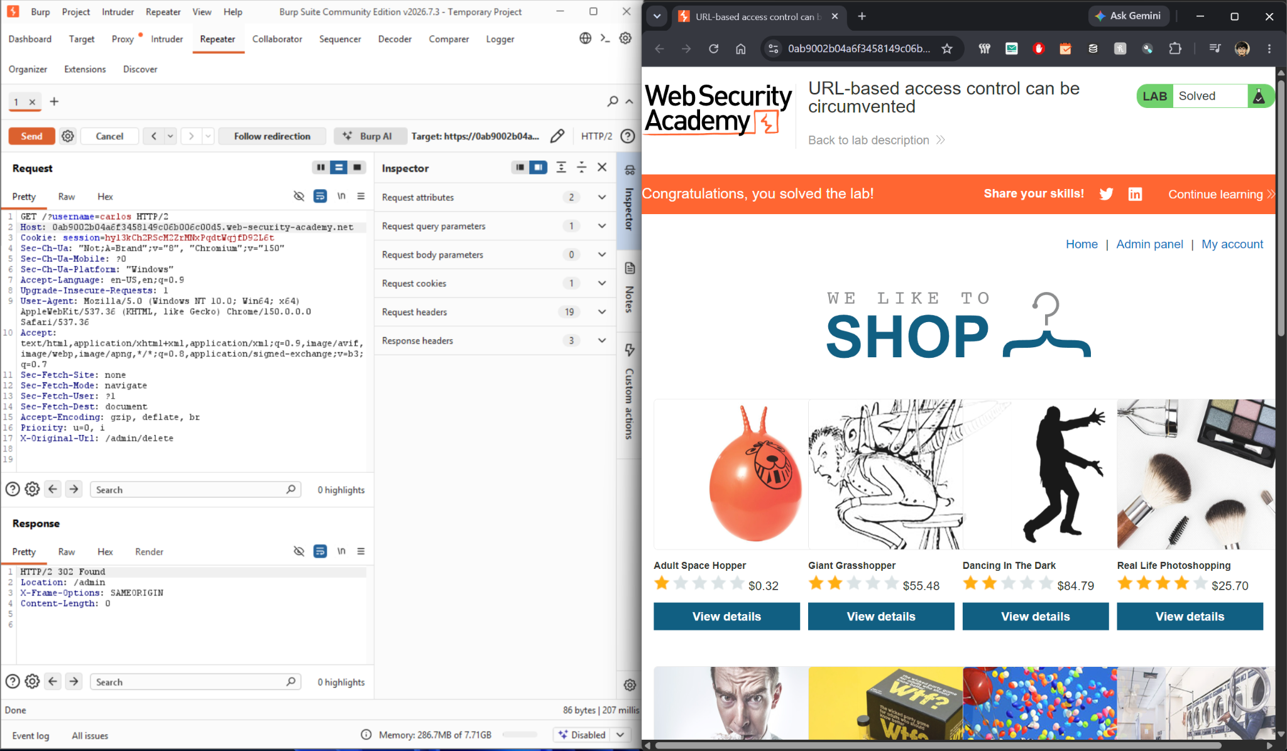

2.6 Impact Assessment

An attacker can completely bypass perimeter URL restrictions to invoke sensitive administrative endpoints (such as user deletion functionality). This leads to vertical privilege escalation, unauthorized modification or destruction of critical system resources, and potential full administrative compromise of the application layer.

2.7 Remediation
Server-Side Authorization: Implement strict, role-based authorization checks directly within the application backend logic for every requested action, rather than relying on front-end or reverse proxy URL filtering.
Disable Header Overrides: Ensure that request header overriding mechanisms (such as X-Original-Url or X-Rewrite-URL) are disabled on production front-end servers unless strictly required, and ensure any accepted headers are validated securely against the authenticated user's session role.

2.8 Conclusion

This lab demonstrates the severe security risks associated with relying solely on URL path filtering and reverse proxy restrictions for access control. Without defence-in-depth authorization checks implemented uniformly across backend application endpoints, perimeter controls remain vulnerable to header manipulation and request smuggling techniques.

References:
- OWASP Top 10: 2025—A01: Broken Access Control.
https://owasp.org/Top10/2021/A01_2021-Broken_Access_Control/
- OWASP Top 10: 2021—A07: Identification and Authentication Failures.
https://owasp.org/Top10/2021/A07_2021-Identification_and_Authentication_Failures/
- IDOR https://portswigger.net/web-security/access-control/idor
- Horizontal Privilege Escalation
https://portswigger.net/web-security/access-control#what-is-access-control
- Vertical Privilege Escalation
https://portswigger.net/web-security/access-control#what-is-access-control
- LAB: URL-based access control can be circumvented—PortSwigger Web Security Academy
https://portswigger.net/web-security/access-control/lab-url-based-access-control-can-be-circumvented

